**PRACTICAL 4**

**AWT**

**Introduction:**

1. Java AWT is an API to develop Graphical User Interface (GUI) or windows-based applications in JAVA
2. Java AWT components are platform-dependent, i.e., Components are displayed according to the view of operation system. Which means the components will have a different look depending on the platform it is run on like Windows, MacOS, Linux, etx.
3. AWT is heavyweight because its components used the resources of the underlying operation system.
4. In short AWT applications will look like a Windows application in Windows whereas it will look like a Mac application in MacOS.
5. The java.aet package provides classes for AWT API components such as TextField, Label, TextArea, RadioButton, CheckBox, Choice, List, etc

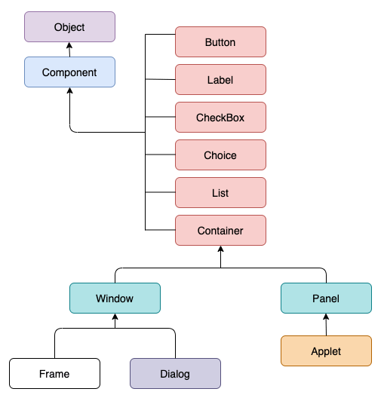**Figure 1: Hierarchy of Container and component classes in AWT**

1. **Components**: All the elements like **button, text fields, scroll bars, etc**, are all called components. In AWT each component has a class. To add a component to the application we need to add them to a **container**
2. **Containers:** 
   1. The container is a components that can contain other components like **buttons, textfields, etc.**
   2. Types of containers:
      1. Window
         1. This container has no borders and menu bars.
         2. You must use frame or dialogue to make use of window container
         3. We need to create an instance of Window class to create this container
      2. Panel
         1. This container doesn’t have title bar, border or menu bar
         2. It is a generic container for holding components like button, textfield, etc.
         3. An instance of Panel class creates a container, in which we can add components.
      3. Frame
         1. Frame is a container that has title bar, border and menu bars.
         2. It can hold other components like button, textfield, scrollbar, etc.
         3. This is the most widely use container while developing an AWT application
      4. Dialog
         1. The dialog control represents a top-level window with a border and a title used to take some form of input from the user.
         2. This container inherits the window class.
         3. Unlike the Frame container, it doesn’t have maximize and minimize buttons

**Q1. Write a program to create an AWT GUI and handle event**

**CODE:**

/*

* To change this license header, choose License Headers in Project Properties.

* To change this template file, choose Tools | Templates

* and open the template in the editor.

*/

package practical_4;

/**

*

* @author shalmon

*/

public class question_1 extends java.awt.Frame {

/**

* Creates new form question_1

*/

public question_1() {

initComponents();

}

/**

* This method is called from within the constructor to initialize the form.

* WARNING: Do NOT modify this code. The content of this method is always

* regenerated by the Form Editor.

*/

// <editor-fold defaultstate="collapsed" desc="Generated Code">

private void initComponents() {

label1 = new java.awt.Label();

label2 = new java.awt.Label();

textField1 = new java.awt.TextField();

textField2 = new java.awt.TextField();

button1 = new java.awt.Button();

label3 = new java.awt.Label();

label4 = new java.awt.Label();

setCursor(new java.awt.Cursor(java.awt.Cursor.DEFAULT_CURSOR));

setMinimumSize(new java.awt.Dimension(400, 350));

addWindowListener(new java.awt.event.WindowAdapter() {

public void windowClosing(java.awt.event.WindowEvent evt) {

exitForm(evt);

}

});

setLayout(new org.netbeans.lib.awtextra.AbsoluteLayout());

label1.setText("Username:");

add(label1, new org.netbeans.lib.awtextra.AbsoluteConstraints(70, 90, -1, -1));

label2.setText("Password:");

add(label2, new org.netbeans.lib.awtextra.AbsoluteConstraints(70, 130, -1, -1));

add(textField1, new org.netbeans.lib.awtextra.AbsoluteConstraints(180, 90, 90, -1));

add(textField2, new org.netbeans.lib.awtextra.AbsoluteConstraints(180, 130, 90, -1));

button1.setLabel("Login");

button1.setName(""); // NOI18N

button1.addActionListener(new java.awt.event.ActionListener() {

public void actionPerformed(java.awt.event.ActionEvent evt) {

button1ActionPerformed(evt);

}

});

add(button1, new org.netbeans.lib.awtextra.AbsoluteConstraints(140, 180, -1, -1));

label3.setText("Success");

label3.setVisible(false);

add(label3, new org.netbeans.lib.awtextra.AbsoluteConstraints(140, 240, -1, -1));

label4.setText("ENTER DETAILS FIRST!!");

label4.setVisible(false);

add(label4, new org.netbeans.lib.awtextra.AbsoluteConstraints(140, 240, -1, -1));

pack();

}// </editor-fold>

/**

* Exit the Application

*/

private void exitForm(java.awt.event.WindowEvent evt) {

System.exit(0);

}

private void button1ActionPerformed(java.awt.event.ActionEvent evt) {

if(textField1.getText().length() > 0 && textField2.getText().length() > 0){

label4.setVisible(false);

label3.setVisible(true);

}

else{

label3.setVisible(false);

label4.setVisible(true);

}

}

/**

* @param args the command line arguments

*/

public static void main(String args[]) {

java.awt.EventQueue.invokeLater(new Runnable() {

public void run() {

new question_1().setVisible(true);

}

});

}

// Variables declaration - do not modify

private java.awt.Button button1;

private java.awt.Label label1;

private java.awt.Label label2;

private java.awt.Label label3;

private java.awt.Label label4;

private java.awt.TextField textField1;

private java.awt.TextField textField2;

// End of variables declaration

}

**OUTPUT:**

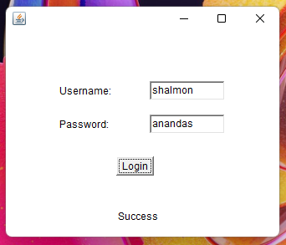 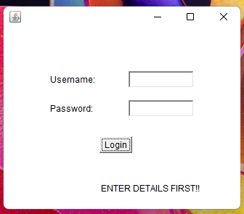

**Q2. Write a program to create an AWT GUI and perform the following operation**

**CODE:**

/*

* To change this license header, choose License Headers in Project Properties.

* To change this template file, choose Tools | Templates

* and open the template in the editor.

*/

package practical_4;

/**

*

* @author shalmon

*/

public class question_2 extends java.awt.Frame {

/**

* Creates new form question_2

*/

public question_2() {

initComponents();

}

/**

* This method is called from within the constructor to initialize the form.

* WARNING: Do NOT modify this code. The content of this method is always

* regenerated by the Form Editor.

*/

// <editor-fold defaultstate="collapsed" desc="Generated Code">

private void initComponents() {

label1 = new java.awt.Label();

label2 = new java.awt.Label();

label3 = new java.awt.Label();

textField1 = new java.awt.TextField();

textField2 = new java.awt.TextField();

button1 = new java.awt.Button();

button2 = new java.awt.Button();

button3 = new java.awt.Button();

button4 = new java.awt.Button();

button5 = new java.awt.Button();

label4 = new java.awt.Label();

textField3 = new java.awt.TextField();

setPreferredSize(new java.awt.Dimension(400, 300));

addWindowListener(new java.awt.event.WindowAdapter() {

public void windowClosing(java.awt.event.WindowEvent evt) {

exitForm(evt);

}

});

setLayout(new org.netbeans.lib.awtextra.AbsoluteLayout());

label1.setFont(new java.awt.Font("Dialog", 1, 18)); // NOI18N

label1.setName(""); // NOI18N

label1.setText("CALCULATOR");

add(label1, new org.netbeans.lib.awtextra.AbsoluteConstraints(130, 40, -1, -1));

label2.setText("Enter First Number:");

add(label2, new org.netbeans.lib.awtextra.AbsoluteConstraints(30, 90, -1, -1));

label3.setText("Enter Second Number:");

add(label3, new org.netbeans.lib.awtextra.AbsoluteConstraints(30, 130, -1, -1));

add(textField1, new org.netbeans.lib.awtextra.AbsoluteConstraints(210, 90, 150, -1));

add(textField2, new org.netbeans.lib.awtextra.AbsoluteConstraints(210, 130, 150, -1));

button1.setLabel("ADD");

button1.setName(""); // NOI18N

button1.addActionListener(new java.awt.event.ActionListener() {

public void actionPerformed(java.awt.event.ActionEvent evt) {

button1ActionPerformed(evt);

}

});

add(button1, new org.netbeans.lib.awtextra.AbsoluteConstraints(30, 210, 60, -1));

button2.setLabel("SUB");

button2.addActionListener(new java.awt.event.ActionListener() {

public void actionPerformed(java.awt.event.ActionEvent evt) {

button2ActionPerformed(evt);

}

});

add(button2, new org.netbeans.lib.awtextra.AbsoluteConstraints(120, 210, 60, -1));

button3.setLabel("MUL");

button3.addActionListener(new java.awt.event.ActionListener() {

public void actionPerformed(java.awt.event.ActionEvent evt) {

button3ActionPerformed(evt);

}

});

add(button3, new org.netbeans.lib.awtextra.AbsoluteConstraints(210, 210, 60, -1));

button4.setLabel("DIV");

button4.addActionListener(new java.awt.event.ActionListener() {

public void actionPerformed(java.awt.event.ActionEvent evt) {

button4ActionPerformed(evt);

}

});

add(button4, new org.netbeans.lib.awtextra.AbsoluteConstraints(300, 210, 60, -1));

button5.setLabel("CLEAR");

button5.addActionListener(new java.awt.event.ActionListener() {

public void actionPerformed(java.awt.event.ActionEvent evt) {

button5ActionPerformed(evt);

}

});

add(button5, new org.netbeans.lib.awtextra.AbsoluteConstraints(120, 250, 150, -1));

label4.setText("Result:");

add(label4, new org.netbeans.lib.awtextra.AbsoluteConstraints(30, 170, -1, -1));

add(textField3, new org.netbeans.lib.awtextra.AbsoluteConstraints(210, 170, 150, -1));

pack();

}// </editor-fold>

/**

* Exit the Application

*/

private void exitForm(java.awt.event.WindowEvent evt) {

System.exit(0);

}

private void button3ActionPerformed(java.awt.event.ActionEvent evt) {

int a = Integer.parseInt(textField1.getText());

int b = Integer.parseInt(textField2.getText());

int c = a * b;

textField3.setText(String.valueOf(c));

}

private void button1ActionPerformed(java.awt.event.ActionEvent evt) {

int a = Integer.parseInt(textField1.getText());

int b = Integer.parseInt(textField2.getText());

int c = a + b;

textField3.setText(String.valueOf(c));

}

private void button2ActionPerformed(java.awt.event.ActionEvent evt) {

int a = Integer.parseInt(textField1.getText());

int b = Integer.parseInt(textField2.getText());

int c = a - b;

textField3.setText(String.valueOf(c));

}

private void button4ActionPerformed(java.awt.event.ActionEvent evt) {

int a = Integer.parseInt(textField1.getText());

int b = Integer.parseInt(textField2.getText());

int c = a / b;

textField3.setText(String.valueOf(c));

}

private void button5ActionPerformed(java.awt.event.ActionEvent evt) {

textField1.setText("");

textField2.setText("");

textField3.setText("");

}

/**

* @param args the command line arguments

*/

public static void main(String args[]) {

java.awt.EventQueue.invokeLater(new Runnable() {

public void run() {

new question_2().setVisible(true);

}

});

}

// Variables declaration - do not modify

private java.awt.Button button1;

private java.awt.Button button2;

private java.awt.Button button3;

private java.awt.Button button4;

private java.awt.Button button5;

private java.awt.Label label1;

private java.awt.Label label2;

private java.awt.Label label3;

private java.awt.Label label4;

private java.awt.TextField textField1;

private java.awt.TextField textField2;

private java.awt.TextField textField3;

// End of variables declaration

}

**OUTPUT:**

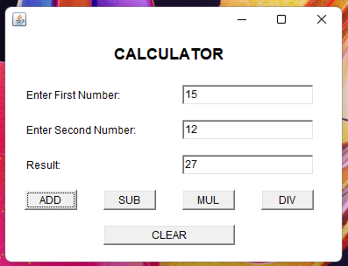 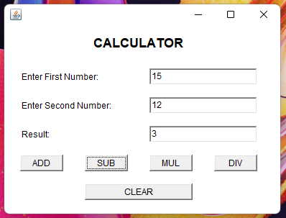

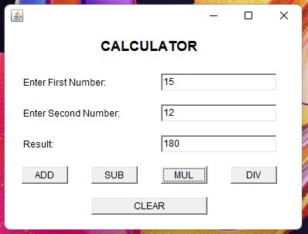 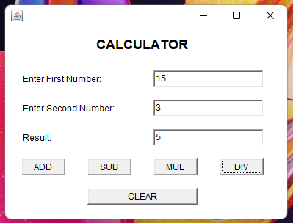

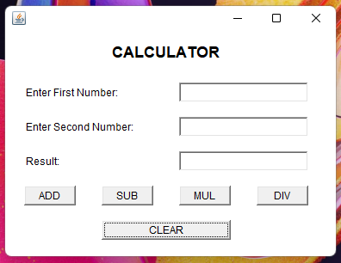

**Clear**

**Q3. Write a program to create an AWT GUI**

**CODE:**

/*

* To change this license header, choose License Headers in Project Properties.

* To change this template file, choose Tools | Templates

* and open the template in the editor.

*/

package practical_4;

/**

*

* @author shalmon

*/

public class question_3 extends java.awt.Frame {

/**

* Creates new form question_3

*/

public question_3() {

initComponents();

}

/**

* This method is called from within the constructor to initialize the form.

* WARNING: Do NOT modify this code. The content of this method is always

* regenerated by the Form Editor.

*/

// <editor-fold defaultstate="collapsed" desc="Generated Code">

private void initComponents() {

label1 = new java.awt.Label();

textField1 = new java.awt.TextField();

label2 = new java.awt.Label();

label3 = new java.awt.Label();

textField2 = new java.awt.TextField();

label4 = new java.awt.Label();

checkbox1 = new java.awt.Checkbox();

checkbox2 = new java.awt.Checkbox();

checkbox3 = new java.awt.Checkbox();

button1 = new java.awt.Button();

label5 = new java.awt.Label();

addWindowListener(new java.awt.event.WindowAdapter() {

public void windowClosing(java.awt.event.WindowEvent evt) {

exitForm(evt);

}

});

setLayout(new org.netbeans.lib.awtextra.AbsoluteLayout());

label1.setName(""); // NOI18N

label1.setText("Name:");

add(label1, new org.netbeans.lib.awtextra.AbsoluteConstraints(40, 40, -1, -1));

textField1.addActionListener(new java.awt.event.ActionListener() {

public void actionPerformed(java.awt.event.ActionEvent evt) {

textField1ActionPerformed(evt);

}

});

add(textField1, new org.netbeans.lib.awtextra.AbsoluteConstraints(160, 40, 190, -1));

label2.setText("Student Details:");

add(label2, new org.netbeans.lib.awtextra.AbsoluteConstraints(40, 80, -1, -1));

label3.setText("Contact Number:");

add(label3, new org.netbeans.lib.awtextra.AbsoluteConstraints(40, 120, -1, -1));

add(textField2, new org.netbeans.lib.awtextra.AbsoluteConstraints(160, 120, 190, -1));

label4.setText("Course Offered:");

add(label4, new org.netbeans.lib.awtextra.AbsoluteConstraints(40, 160, -1, -1));

checkbox1.setLabel("Bioinformatics");

add(checkbox1, new org.netbeans.lib.awtextra.AbsoluteConstraints(160, 160, -1, -1));

checkbox2.setLabel("Botany");

add(checkbox2, new org.netbeans.lib.awtextra.AbsoluteConstraints(160, 190, -1, -1));

checkbox3.setLabel("Biochemistry");

add(checkbox3, new org.netbeans.lib.awtextra.AbsoluteConstraints(160, 220, -1, -1));

button1.setLabel("SUBMIT");

button1.addActionListener(new java.awt.event.ActionListener() {

public void actionPerformed(java.awt.event.ActionEvent evt) {

button1ActionPerformed(evt);

}

});

add(button1, new org.netbeans.lib.awtextra.AbsoluteConstraints(290, 250, -1, -1));

label5.setText("Successfull!!!");

label5.setVisible(false);

add(label5, new org.netbeans.lib.awtextra.AbsoluteConstraints(40, 250, 80, -1));

pack();

}// </editor-fold>

/**

* Exit the Application

*/

private void exitForm(java.awt.event.WindowEvent evt) {

System.exit(0);

}

private void textField1ActionPerformed(java.awt.event.ActionEvent evt) {

// TODO add your handling code here:

}

private void button1ActionPerformed(java.awt.event.ActionEvent evt) {

if(textField1.getText().length() > 0 && textField2.getText().length() > 0){

label5.setText("Successfull!!");

label5.setVisible(true);

}

else{

label5.setText("Enter Details!!");

label5.setVisible(true);

}

}

/**

* @param args the command line arguments

*/

public static void main(String args[]) {

java.awt.EventQueue.invokeLater(new Runnable() {

public void run() {

new question_3().setVisible(true);

}

});

}

// Variables declaration - do not modify

private java.awt.Button button1;

private java.awt.Checkbox checkbox1;

private java.awt.Checkbox checkbox2;

private java.awt.Checkbox checkbox3;

private java.awt.Label label1;

private java.awt.Label label2;

private java.awt.Label label3;

private java.awt.Label label4;

private java.awt.Label label5;

private java.awt.TextField textField1;

private java.awt.TextField textField2;

// End of variables declaration

}

**OUTPUT:**

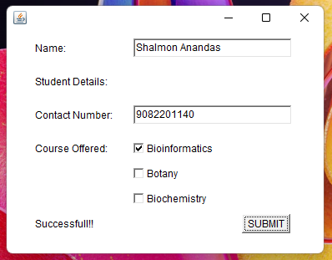 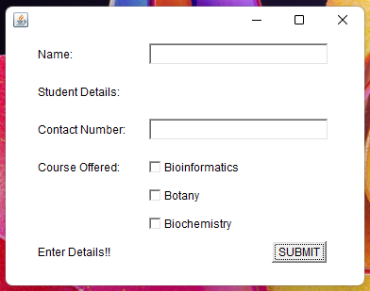

**Q4. Write a program to create a GUI and add MouseListener**

**CODE:**

/*

* To change this license header, choose License Headers in Project Properties.

* To change this template file, choose Tools | Templates

* and open the template in the editor.

*/

package practical_4;

/**

*

* @author shalmon

*/

public class question_4 extends java.awt.Frame {

/**

* Creates new form question_4

*/

public question_4() {

initComponents();

}

/**

* This method is called from within the constructor to initialize the form.

* WARNING: Do NOT modify this code. The content of this method is always

* regenerated by the Form Editor.

*/

// <editor-fold defaultstate="collapsed" desc="Generated Code">

private void initComponents() {

textField1 = new java.awt.TextField();

setBackground(java.awt.Color.blue);

setMinimumSize(new java.awt.Dimension(400, 300));

addWindowListener(new java.awt.event.WindowAdapter() {

public void windowClosing(java.awt.event.WindowEvent evt) {

exitForm(evt);

}

});

setLayout(new org.netbeans.lib.awtextra.AbsoluteLayout());

textField1.setFont(new java.awt.Font("Dialog", 1, 12)); // NOI18N

textField1.setForeground(new java.awt.Color(255, 0, 0));

textField1.addMouseListener(new java.awt.event.MouseAdapter() {

public void mouseClicked(java.awt.event.MouseEvent evt) {

textField1MouseClicked(evt);

}

public void mouseEntered(java.awt.event.MouseEvent evt) {

textField1MouseEntered(evt);

}

public void mouseExited(java.awt.event.MouseEvent evt) {

textField1MouseExited(evt);

}

});

add(textField1, new org.netbeans.lib.awtextra.AbsoluteConstraints(70, 110, 260, 50));

pack();

}// </editor-fold>

/**

* Exit the Application

*/

private void exitForm(java.awt.event.WindowEvent evt) {

System.exit(0);

}

private void textField1MouseEntered(java.awt.event.MouseEvent evt) {

textField1.setText("Mouse Entered");

}

private void textField1MouseExited(java.awt.event.MouseEvent evt) {

textField1.setText("Mouse Exited");

}

private void textField1MouseClicked(java.awt.event.MouseEvent evt) {

textField1.setText("Mouse Clicked");

}

/**

* @param args the command line arguments

*/

public static void main(String args[]) {

java.awt.EventQueue.invokeLater(new Runnable() {

public void run() {

new question_4().setVisible(true);

}

});

}

// Variables declaration - do not modify

private java.awt.TextField textField1;

// End of variables declaration

}

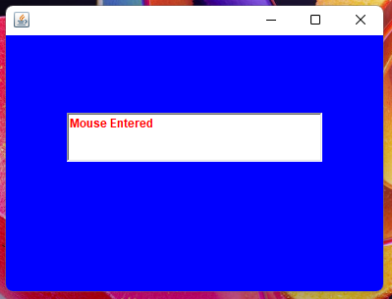**OUTPUT:**

